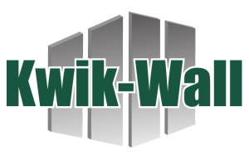


AIA Continuing Education Program Summary

Provider: Kwik-Wall Company LU/HSW: 1 AIA Course Number: 4650C
Course Title: Interior Movable Glass Walls: Optimal aesthetics with flexibility, daylighting, and acoustic performance

Course Description: This course explores the design and specification of interior movable glass walls to achieve optimal aesthetics, spatial flexibility, daylighting, and acoustic performance. Participants will learn strategies to enhance occupant well-being, safety, and functionality through effective layout, material selection, and installation practices.
Learning Objectives
- Understand the applications and product differences between movable interior glass vs exterior walls.
- Review the importance of acoustic performance and how overhead structural, floor support, glass type and surrounding seals effect performance.
- Learn how movable glass walls optimize sustainable building design including materials, indoor air quality and daylighting.
- Review how movable glass partitions add to the human experience within the built environment.

No cost | Delivered live via PowerPoint from presenter laptop | Power and HDMI compatible display are required | Lunch and learn/classroom setting | No prerequisite courses required

For more information or to schedule, please contact:

