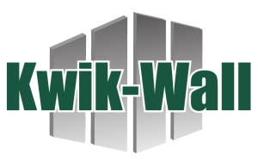


AIA Continuing Education Program Summary

Provider: Kwik-Wall Company LU/HSW: 1 AIA Course Number: 4650B
Course Title: Mastering Operable Partition Design & Specifications

Course Description: Navigate operable partition design with confidence by learning the basics of design and specification writing. Learn the importance of configurations, options, track systems, structural support, operation, informed product selection. Learn how ASTM standards play a role in design and installation. Identify how to write specifications, avoid the pitfalls of shop drawing and submittal review as well as site inspections.
Learning Objectives
- Identify different types of operable partitions and determine appropriate applications.
- Understand how configuration, stacking, and suspension systems impact design and usability.
- Write competitive, accurate specifications for operable partitions that meet project requirements.
- Apply best architectural practices for reviewing operable partition submittals.

No cost | Delivered live via PowerPoint from presenter laptop | Power and HDMI compatible display are required | Lunch and learn/classroom setting | No prerequisite courses required

For more information or to schedule, please contact:

